**Department of Information Technology**

**MINI PROJECT REPORT**

**ON**

**Personalized Diet Chart**

**Generator Website**

**Submitted By:**

**Varun Saxena (2200910130188)**



**JSS Academy of Technical Education, NOIDA**

**Dr. APJ Abdul Kalam Technical University, Lucknow, U.P**

**Session 2023-24**

**VISION AND MISSION**

**VISION OF THE INSTITUTE**

“JSS Academy of Technical Education Noida aims to become an Institution of excellence in imparting quality Outcome Education that empowers the young generation with Knowledge, Skills, Research, Aptitude, and Ethical values to solve Contemporary Challenging Problems.”

**MISSION OF THE INSTITUTE**

Develop a platform for achieving a globally acceptable level of intellectual acumen and technological competence.

Create an inspiring ambiance that raises the motivation level for conducting quality research.

Provide an environment for acquiring ethical values and a positive attitude.

**VISION OF THE DEPARTMENT**

“To become a Centre of Excellence in teaching and research in Information Technology for producing skilled professionals having the zeal to serve society”.”

**MISSION OF THE DEPARTMENT**

To create an environment where students can be equipped with strong fundamental concepts, programming, and problem-solving skills.

To provide exposure to emerging technologies by providing hands-on experience for generating competent professionals.

To promote Research and Development in the frontier areas of Information Technology and encourage students to pursue higher education

To inculcate in students ethics, professional values, teamwork, and leadership skills.

**DECLARATION**

I hereby affirm that the project titled "**Personalized Diet Chart Generator Website**" presented to Dr. APJ Abdul Kalam Technical University, Uttar Pradesh, Lucknow, represents my original work. Under the mentorship of **Mrs. Ujwala Thakur.** I conducted this research as part of the requirements for obtaining the degree of Bachelor of Technology in Information Technology. The findings and results presented in this project have not been previously submitted to any other academic institution for any degree.

**Signature:**

**Name: Varun Saxena**

**Roll No: 2200910130188**

**Date: 12/02/2022**

## CERTIFICATE

This is to certify that "**Varun Saxena**” in his Second year of Information Technology Engineering has submitted a Minor Project report entitled “**Personalized Diet Chart Generator**" in Partial fulfillment for the award of a Bachelor of Technology Degree of Dr. APJ Abdul Kalam Technical University, Uttar Pradesh, Lucknow in session 2023-24. It is satisfactory and hereby approved for submission.

**Supervisor:**

**Date: 12/12/2022**

**ACKNOWLEDGMENT**

"A teacher affects eternity; he can never tell where his influence stops." We extend our heartfelt gratitude to **Dr. Dhiraj Pandey** of the Information Technology Engineering Department, whose guidance enabled us to flawlessly execute this project.

I also extend our sincere appreciation to the Information Technology Department for their dedicated efforts in mentoring us.

I am thankful for the valuable input provided by our seniors, which greatly contributed to the success of this project. Should there be any oversights or mistakes, I apologize and welcome feedback. On a personal note, I express our deepest gratitude to our families and friends for their unwavering support and encouragement. They have been our constant source of strength.

I earnestly hope that this project meets your expectations and standards.

**Name: Varun Saxena**

**Roll. No.: 2200910130188**

**Date: 12/02/2022**

**ABSTRACT**

This report outlines the project undertaken by our group, detailing our efforts across five chapters. The development of the Personalized Diet Chart Generator Website equipped us with essential skills in web development, user-centric design, and dynamic content implementation. Through proficiency in HTML, CSS, and JavaScript, we structured the site's layout, enhanced its visual presentation, and implemented interactive features. We optimized multimedia elements for an engaging user experience. Version control systems facilitated collaboration and project management, ensuring efficient development processes. Lastly, web hosting services enabled the deployment of the website, making it accessible to users worldwide. This project fostered teamwork, problem-solving, and communication skills essential for successful web development endeavors. Furthermore, we explore the domains where this technology finds application. The report is supplemented with the credibility and thoroughness of our research efforts.

**TABLE OF CONTENTS**

|  |  |  |
| --- | --- | --- |
| Sr. No. | Topic | Page No. |
| 1 | List of Figures | 9 |
| 2 | Objectives | 10 |
| 3 | Technology Used | 11 |
| 4 | Utility | 13 |
| 5 | Learning Outcomes | 14 |
| 6 | **Conclusion and Future Scope** | 16 |

**LIST OF FIGURES**

* **Fig 1: Balanced Diet**
* Fig 2: HTML Logo
* Fig 3: CSS Logo
* Fig 4: JavaScript Logo
* Fig 5: Canva Logo
* Fig: 6 About this Website
* Fig 7: Screenshot of the Website

**Chapter 1: OBJECTIVE**

The primary objective of our mini project was to develop a Personalized Diet Chart Generator Website aimed at revolutionizing the way individuals engage with their dietary habits. We aimed to create a platform that provides tailored and customized diet plans considering individual factors such as age, gender, health goals, dietary preferences, and cultural backgrounds. Through this project, we sought to empower users to make informed dietary decisions, promote healthy eating habits, and ultimately improve their overall well-being.

We recognized the imperative for a personalized approach to nutrition that accounts for diverse individual factors such as age, gender, health objectives, dietary inclinations, and cultural backgrounds. By harnessing the power of technology and data-driven insights, our objective is clear: to equip users with the tools and knowledge needed to make enlightened dietary decisions that foster enduring health and vitality.

Through our platform, we aspire to shift the narrative surrounding nutrition, empowering users to transcend the confines of fad diets and generic recommendations. Instead, we strive to facilitate a deeper understanding of the intricate relationship between diet and well-being, empowering individuals to cultivate sustainable dietary habits tailored to their unique needs. Our ultimate goal is to ignite a paradigm shift towards a healthier, more nourished society.

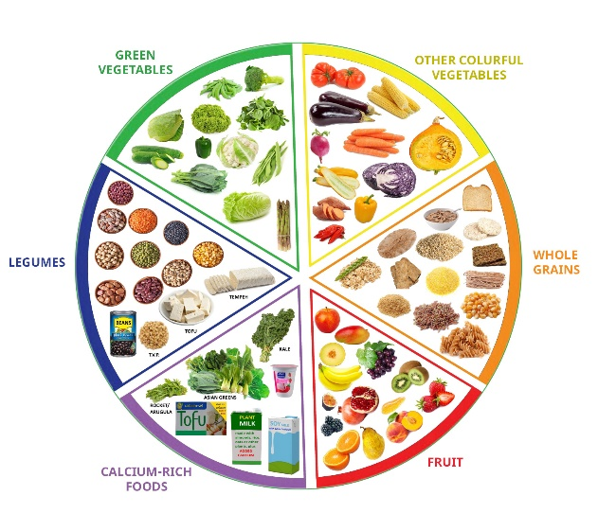

**Fig 1: Balanced Diet**

**Chapter 2: TECHNOLOGIES USED**

The development of the Personalized Diet Chart Generator Website involved the use of the following tools and technologies:

* **HTML (Hypertext Markup Language):** HTML is the standard markup language used to create the structure and content of web pages. It provides a set of elements or tags that define the various components of a webpage, such as headings, paragraphs, images, links, and forms. HTML serves as the backbone of web development, laying the foundation upon which CSS and JavaScript are built.



Fig 2: HTML Logo

* **CSS (Cascading Style Sheets):** CSS is a style sheet language used to control the visual presentation and layout of HTML elements on a webpage. It allows developers to define styles such as colors, fonts, margins, padding, and positioning, thereby enhancing the appearance and aesthetic appeal of the website. CSS works in conjunction with HTML to create visually appealing and user-friendly web interfaces.



Fig 3: CSS Logo

* **JavaScript:** JavaScript is a versatile programming language used for adding dynamic functionality, interactivity, and behavior to web pages. It enables developers to create features such as interactive forms, animated elements, content updates without page reloads (AJAX), and client-side data validation. JavaScript is essential for enhancing user experience and making web applications more engaging and responsive.



Fig 4: JavaScript Logo

* **Image Editing Software:** Image editing software such as Adobe Photoshop and Canva are used to edit and optimize images used in the design of the website. This includes tasks such as cropping, resizing, adjusting colors and contrast, removing backgrounds, and optimizing file sizes to ensure fast loading times and optimal visual quality on the web.



Fig 5: Canva Logo

* **Web Hosting Service**: A web hosting service is used for deploying the website online and making it accessible to users over the internet. It provides server space, storage, bandwidth, and other resources needed to host and serve the website's files to visitors' browsers. Web hosting services may offer various features such as domain registration, security measures, backups, and technical support to ensure the smooth operation of the website.

**Chapter 3: UTILITY**

The Personalized Diet Chart Generator Website holds significant utility for various applications within the field of Computer Science and Information Technology. Some of the key areas where this project can be beneficial include:

* **Health and Wellness Applications**: The website can be integrated into health and wellness platforms, providing users with personalized nutrition plans to support their fitness goals.
* **Educational Resources**: The project can serve as an educational tool for students studying nutrition, dietetics, or web development, offering practical insights into the application of technology in the field of health.
* **Healthcare Industry**: Healthcare professionals such as dietitians and nutritionists can utilize the website to create customized diet plans for their clients, enhancing the efficiency and effectiveness of their services.
* **Research and Development**: The data collected through user interactions with the website can be valuable for research purposes, enabling the analysis of dietary trends and patterns.
* **Community Engagement**: The website can foster a sense of community among users interested in health and nutrition, facilitating the sharing of experiences, recipes, and tips for maintaining a healthy lifestyle.

**Chapter 4: LEARNING OUTCOMES**

Through the development of the Personalized Diet Chart Generator Website, we have gained invaluable knowledge and skills in the following areas:

1. **Proficiency in HTML, CSS, and JavaScript for web development:** Through this project, we have deepened our understanding and proficiency in the foundational languages of web development. HTML (Hypertext Markup Language) is used for structuring the content of web pages, CSS (Cascading Style Sheets) is employed for styling and designing the visual presentation, and JavaScript is utilized for adding dynamic functionality and interactivity to the website.
2. **Understanding of user-centric design principles and UI/UX considerations**: We have learned the importance of designing user interfaces (UI) and user experiences (UX) that prioritize the needs and preferences of the end-users. This involves considerations such as intuitive navigation, clear visual hierarchy, consistency in design elements, and accessibility for users with disabilities.
3. **Implementation of dynamic content generation and data manipulation using JavaScript**: JavaScript's versatility allowed us to implement dynamic features on the website, such as generating personalized diet charts based on user input and manipulating data to provide relevant recommendations. This includes tasks like form validation, handling user inputs, and updating content dynamically without page reloads.
4. **Integration of multimedia elements such as images and videos into web pages**: We have acquired skills in integrating multimedia elements, including images and videos, to enhance the visual appeal and engagement of the website. This includes techniques for optimizing media files for web delivery and ensuring compatibility across different browsers and devices.
5. **Familiarity with responsive web design techniques for optimal viewing across devices**: In today's multi-device landscape, ensuring that the website is accessible and user-friendly across various screen sizes and devices is crucial. We have learned about responsive web design techniques such as flexible grids, media queries, and fluid layouts to create a seamless viewing experience for users on desktops, tablets, and smartphones.
6. **Collaboration and teamwork in a project-based environment:** Working on this project in a team setting has honed our collaborative skills, including effective communication, task allocation, and coordination. We have learned to leverage each team member's strengths and expertise to achieve common goals and deliver high-quality results within specified timelines.
7. **Problem-solving skills in overcoming technical challenges and debugging code:** Throughout the development process, we encountered various technical challenges and bugs that required systematic problem-solving approaches. We have developed

proficiency in troubleshooting issues, identifying root causes, and implementing effective solutions through experimentation and research.

1. **Project management skills including planning, organization, and task delegation:** Managing a project involves planning, organizing, and coordinating tasks to ensure smooth progress and timely completion. We have gained experience in creating project timelines, setting milestones, allocating resources, and delegating responsibilities to team members based on their strengths and expertise.
2. **Communication skills through documentation, presentation, and teamwork:** Effective communication is essential for successful project execution. We have honed our communication skills through tasks such as documenting project requirements, progress updates, and meeting minutes, as well as delivering presentations to stakeholders. Additionally, collaboration within the team has enhanced our ability to communicate ideas, share feedback, and resolve conflicts constructively.

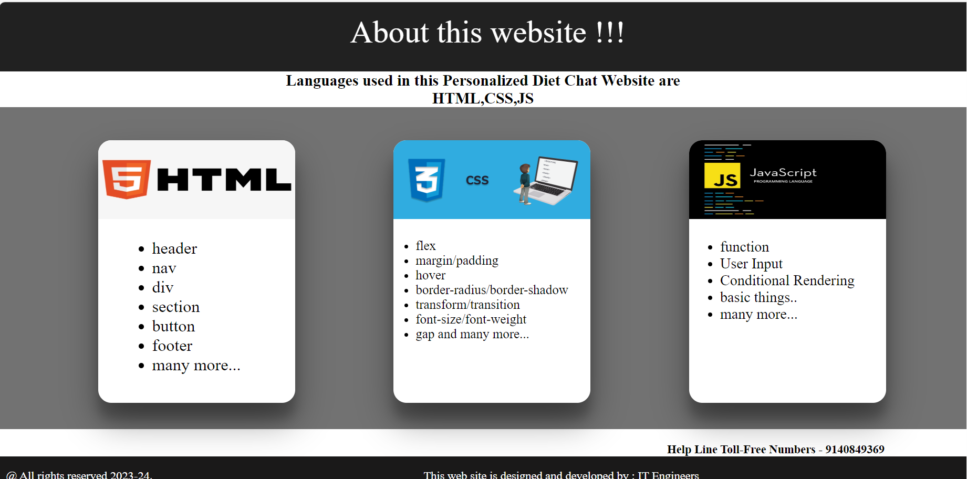

Fig: 6 About this Website

**Chapter 5: CONCLUSION AND FUTURE SCOPE**

In conclusion, the development of the Personalized Diet Chart Generator Website has been a rewarding learning experience that has equipped us with valuable skills in web development and problem-solving. Moving forward, there is immense potential for further enhancement and expansion of the project. Some future scope areas include:

* **Integration of Artificial Intelligence**: Implementing AI algorithms to analyse user data and provide more personalized diet recommendations.
* **Mobile Application Development**: Creating a mobile app version of the website for greater accessibility and convenience.
* **Gamification Elements**: Incorporating gamification elements such as challenges, rewards, and progress tracking to motivate users towards healthier eating habits.
* **Community Features**: Enhancing the website with community forums, recipe-sharing platforms, and social networking features to foster user engagement and interaction.
* **Continuous Improvement**: Regular updates and improvements to the website based on user feedback, technological advancements, and emerging trends in nutrition and wellness.

Overall, the Personalized Diet Chart Generator Website represents a valuable contribution to the intersection of technology and health, empowering individuals to take control of their dietary choices and improve their quality of life.

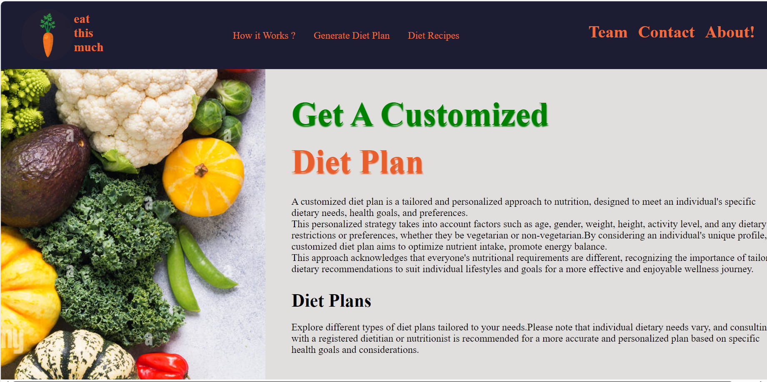

Fig 7: Screenshot of the Website